

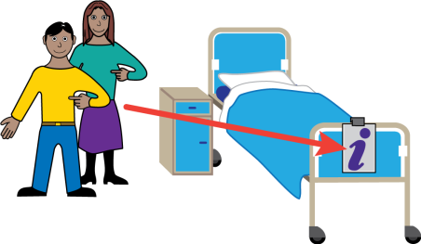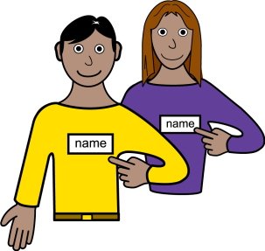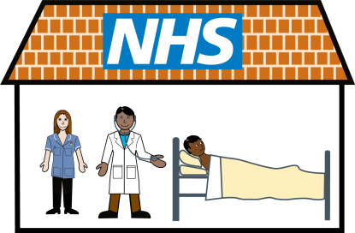­­

**!**

I am an individual; please think about any

**reasonable adjustments** that are needed

to support me. The information in this document will help you to know all about me.

**Please keep this document in the end**

**of bed folder with the Get Me Better**

**magnet and any other appropriate magnets displayed. Please update this document at least once a year or if anything changes**

There is more information about me in the nursing and medical files. I may also have further information like an `All About My Health` or similar document.

There is also useful information provided in the pack with the hospital passport which might be useful during my stay.

**Hospital Passport**

My name is

I like to be called

­­

Hear Me Better!

Treat Me Better!

Speak to Me Better!

Know Me Better!

Feed Me Better!

Make Me Better!

See Me Better!

Support Me Better!

I am­ Better!

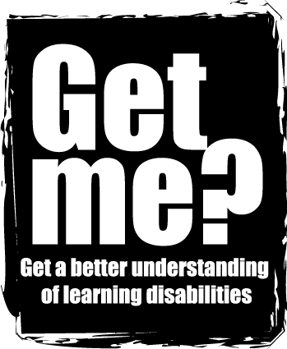

­­­­­­­­

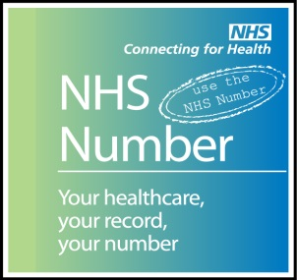

NHS Number:

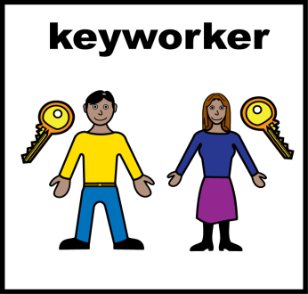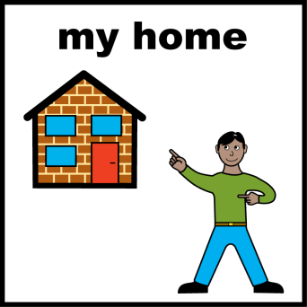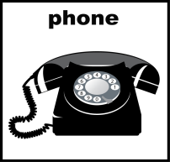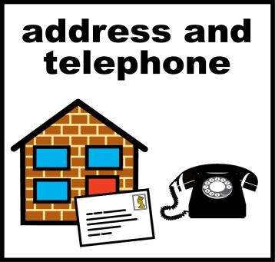

main carer:

Relationship: Tel no:

Where I live: (please circle)

with my family Alone Nursing home

Supported living : I have ………….. hours support each week, provided by: (name of organisation) …………………………………………………………………………

Next of Kin:

Relationship:

Tel no:

Doctor (GP) name and address:

Address:

Tel no: Date of Birth:

Religion

Requests:

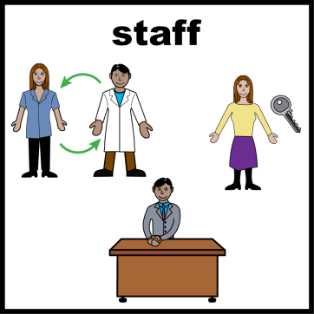

**Professionals involved:**

Name: Tel no:

Job title:

Name: Tel no:

Job title:

Name: Tel no:

Job title:

Name: Tel no:

Job title:

Name: Tel no:

Job title:

Name: Tel no:

Job title:

Name: Tel no:

Job title:

Name: Tel no:

Job title:

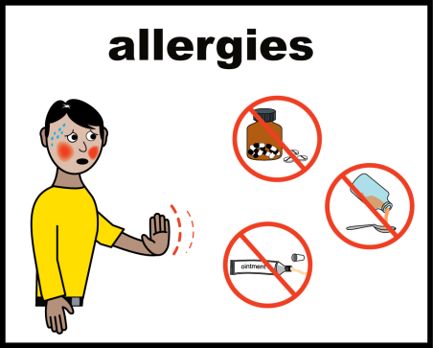

**Allergies:**

Current medical conditions/medical history

(including heart/respiratory problems)

The reason I am at the hospital today

(OPA, Admission, reason)

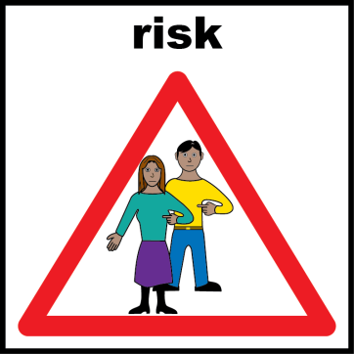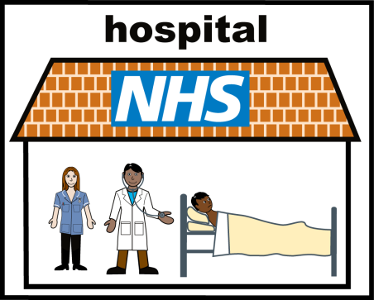

Behaviours that may be challenging or cause risk:

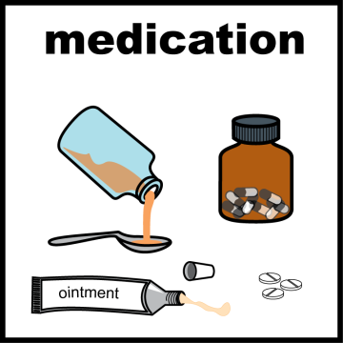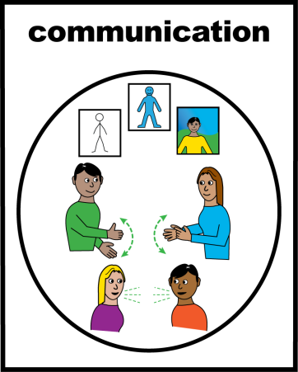

# Communication:

# How to communicate with me, problems with sight or hearing, how to help me understand things.

# My current medication is:

# This how I take my medication (Crushed tablets, injections, syrup, peg).

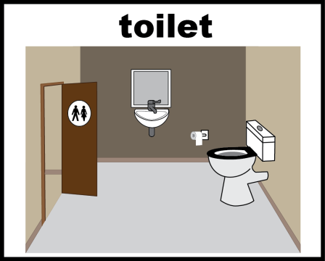­­

**Going to toilet**:

Continence aids, help to get to toilet.

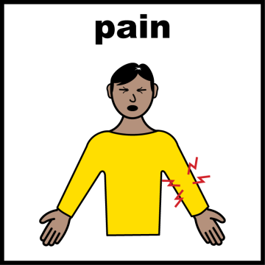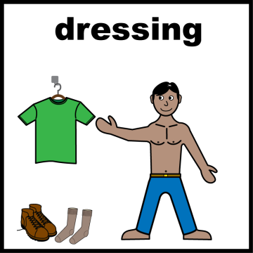

**Pain:**

How you know I am in pain.

**Personal care:**

Dressing, washing etc.

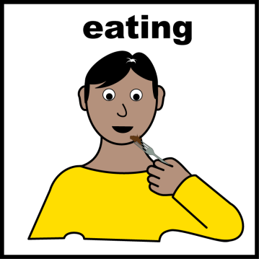

**Drinking and Eating, including any swallowing difficulties**:

Support I need at mealtimes:

My favourite foods are :

I don’t like:

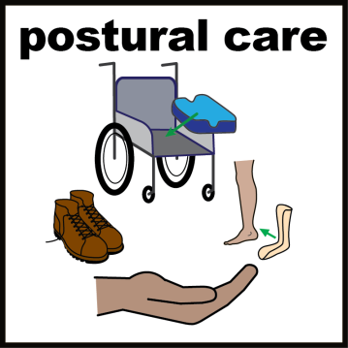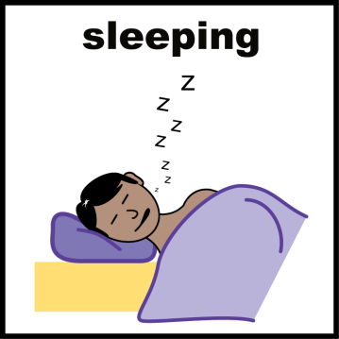

**Moving around**:

Posture in bed, walking aids etc.

**Sleeping**:

Sleep pattern, sleep routine.

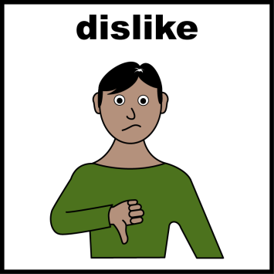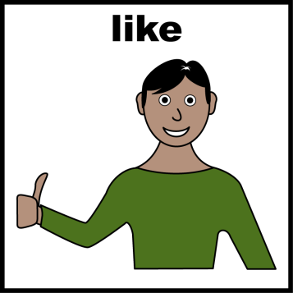

**Things I like** **Things I don’t like**

Please do this: Don’t do this:



**Consent/Capacity**

If any medical decisions are discussed please have a conversation with me or speak to

……………………………………………….……..............................

Their relationship to me is

…………………………………………………………………………..

They will help me to understand the information

I / They will let you know if I have a

PoA Advanced Decision Document

If you need to consider my understanding or any best interest decision please document this here or on the additional information page.

Is there a “**Do Not Attempt cardiac pulmonary resuscitation”** (DNACPR)

Please tick below

Not currently in place In place

In place dated ………………… date ………………….

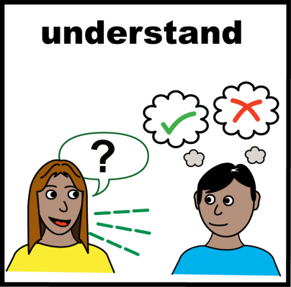

­

­

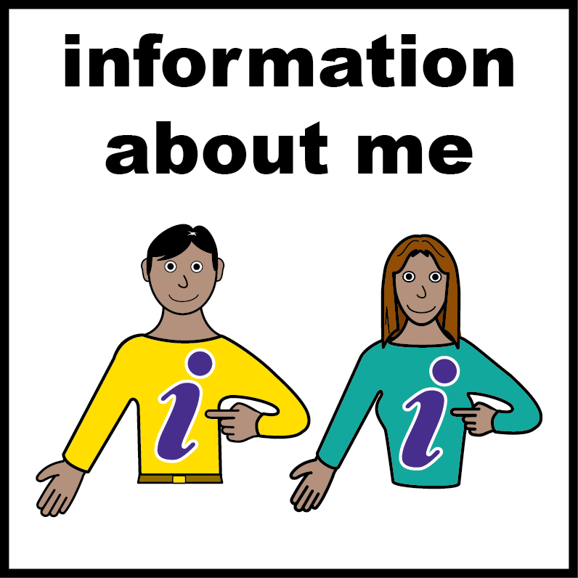

­­

Additional information

­

**Adapted from the Gloucestershire Partnership NHS Trust ‘Hospital Assessment’ form**

Completed by: Date:

Relationship:

Contact details:

Adapted from the Gloucestershire Partnership NHS Trust ‘Hospital Assessment’ form

Adapted from the Gloucestershire Partnership NHS Trust ‘Hospital Assessment’ form

Adapted from the Gloucestershire Partnership NHS Trust ‘Hospital Assessment’ form